**East West University**

**LAB REPORT**

|  |  |
| --- | --- |
| **Course Code and Name:**  CSE 209 ; ELECTRICAL CIRCUIT | |
| **Experiment no: 01**  **Group no: 01** | |
| **Experiment name:**  Introduction to Circuit Elements and Variables | |
| **Name of students & Id:** | |
| **1.** B M Sharhia Alam | **ID:** 2021-3-60-016 |
| **2.** Sidratul Moontaha | **ID:** 2021-3-60-048 |
| **3.** Antara Sarkar Rupa | **ID:** 2021-3-60-056 |
| **Course Instructor information:**  M Saddam Hossain Khan(SHK)  Senior Lecturer  Department of Computer Science and Engineering  East West University | |
| **Date of Report Submitted:**  30 October ,2022 | |

**OBJECTIVE:**

1. To get familiar with circuit variables (voltage and current) and circuit elements (voltage source and resistance).
2. To learn how to measure dc voltage across a circuit element using a voltmeter.
3. To learn how to measure dc current through a circuit element using an ammeter.
4. To learn how to measure resistance of a resistor using a multimeter.
5. To verify Ohm’s Law.

**THEORY:**

There are two types of element in an electrical circuit – active elements and passive elements. An active element provides energy. A voltage source or a battery is an active element. The emf of a battery is measured using the unit potential unit (V). A passive element absorbs energy. A resistor is a passive element. The resistance of a resistor using the unit Ohm (Ω).

There are two fundamental circuit variables – current through a circuit element and voltage across a circuit element. The current through a circuit element is measured using the unit Ampere (A) and the voltage across a circuit element is measure using the unit Volt (V).

A simple electric circuit is shown in Figure 1. The emf of the battery is E Volt and the resistance of the resistor is R. The current drawn from the battery and the current passing through the resistor are same and is I A. The voltage drop across the resistor is V Volt. The voltage drop across the resistor is exactly equal to the emf of the battery, that is, E = V.

The Ohm’s Law states that V = IR. If we plot V vs. I (taking I as independent variable), we have a straight line passing through the origin and the slop of the line is R.

C:\Users\bmsha\AppData\Local\Microsoft\Windows\INetCache\Content.Word\Screenshot (31950).png

Figure 1: A simple electric circuit.

An ammeter is used to measure current and a voltmeter is used to measure voltage. As shown in Figure 2, an ammeter is connected in series with an element, current through which is to be measured. A voltmeter is connected in parallel with an element, voltage across which is to be measured. If you connect an ammeter in parallel with an element, the meter will be damaged. If you connect a voltmeter in series with an element, it will not give you correct result. So, make sure that an ammeter is not connected in parallel and a voltmeter is not connected in series.

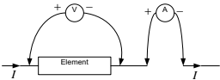

Figure 2. Connection of ammeter and voltmeter.

**CIRCUIT DIAGRAM:**

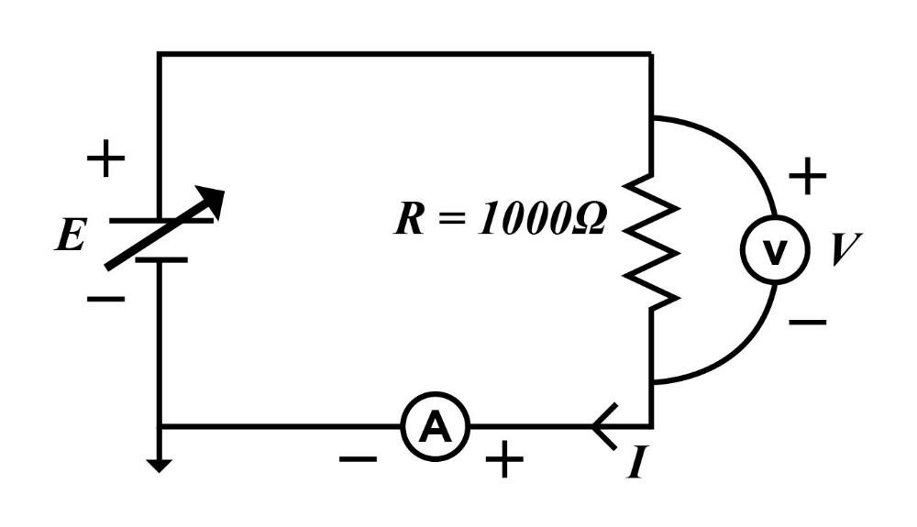

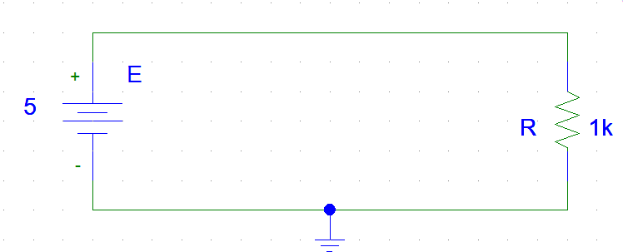

## Figure-3: Circuit for experiment

**Equipments and Components Needed:**

1. DC power supply

2. DC ammeter

3. DC voltmeter

4. Multimeter

5. Resistor 1000

6. Breadboard

7. Connecting wires

**Lab Procedure:**

1. Measure the resistance of the resistor supplied using a multimeter and record it in Table 1.

2. Construct the circuit of Figure 3. Set the value of E at 5, 6, 7, 8, 9, and 10 volts and measure the corresponding V and I and record them in Table 1.

3. Have the datasheet signed by your instructor.

**Experimental Datasheet:**

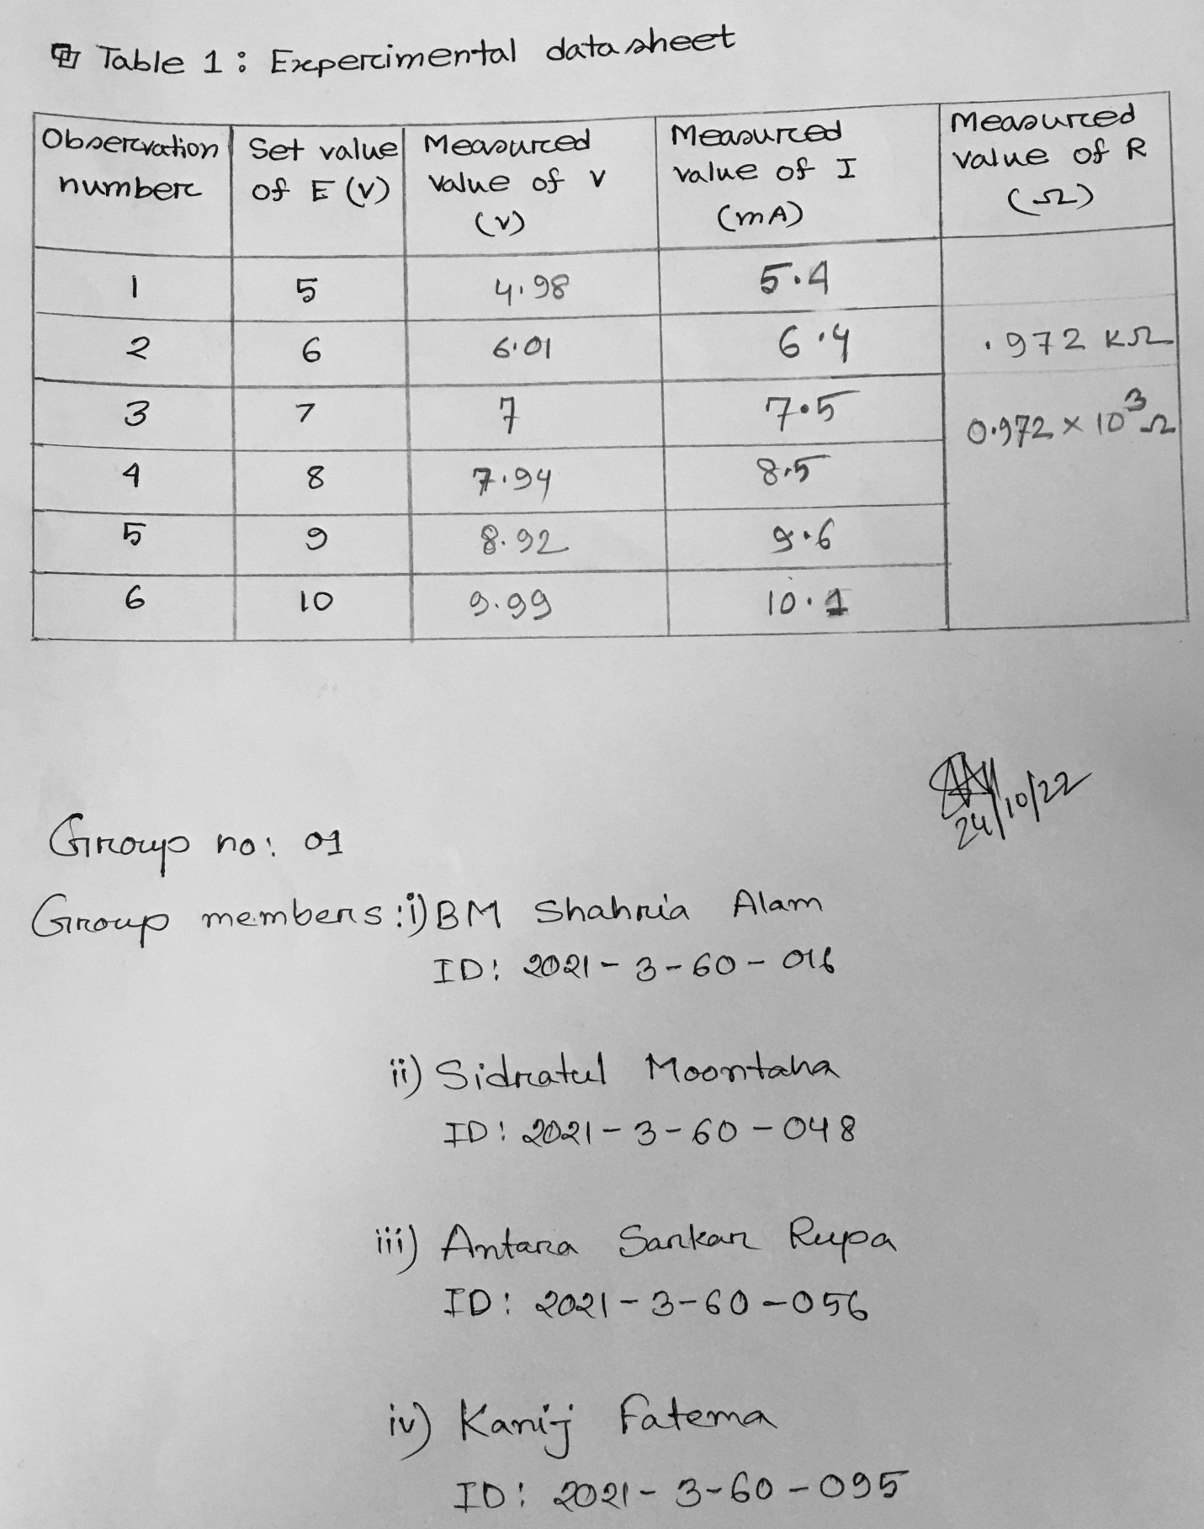

**Answer to the post-lab-report question:**

**ANSWER 1:**

From ohm’s law, we know V = IR

When V = 4.98 V, I= V/R = 4.98/0.972 = 5.12 mA

When V = 6.01 V, I= V/R = 6.01 /0.972 = 6.18 mA

When V = 7 V, I= V/R = 7/0.972 = 7.20 mA

When V = 7.94 V, I= V/R = 7.94/0.972 = 8.17 mA

When V = 8.92 V, I= V/R = 8.92/0.972 = 9.18 mA

When V = 9.99 V, I= V/R = 9.99/0.972 = 10.28 mA

**Comment:** Comparing the theoretical values of I with the measuring values of I, we are noticing some discrepancies here.

**ANSWER 2:**

According to Ohm’s law we know,

 V=IR or

R= V/I ……(1)

Where V=Voltage, I=Current & R=Resistance

Here,

Measured values of Current,

 I= 5.4mA, 6.4mA, 7.5mA, 8.5mA, 9.6mA, 10.1mA.

Measured values of Voltage,

V= 4.98V, 6.01V, 7V, 7.94V, 8.92V, 9.99V

From equation (1),

When V = 4.98V, R== kΩ

When V = 6.01V, R==

When V = 7V, R==

When V = 7.94V, R==Ω

When V = 8.92V, R== kΩ

When V = 9.99V, R== kΩ

The measured value of R is 0.972kΩ.

**Comment:** We can see that there is some difference between the theoretical and measured values of R. Because the experiment was done physically, we faced different technical issues during the lab period.

**ANSWER 3:**

|  |  |
| --- | --- |
| **Set Value of *E* (V)** | **Measured value of *V* (V)** |
| 5 | 4.98 |
| 6 | 6.01 |
| 7 | 7 |
| 8 | 7.91 |
| 9 | 8.92 |
| 10 | 9.99 |

**Comment:** We were unable to ensure accurate values of V because our experiment was done in a physical lab.

**ANSWER 4:**

Using PSpice app we generated the V vs. I graph (taking I as independent variable) and fit a straight-line passing through the origin.

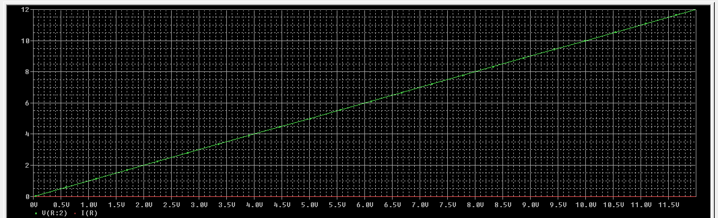

In answer number 2, we used Ohm's Law to theoretically calculate R. For different values of I and V the values of R are kΩ, , Ω, kΩ, kΩ and since the plot above was made using PSpice simulation we can say that the measured value of R and the theoretical value of R is not same and there are some discrepancies.

**ANSWER 5:**

A digital multi-range meter is mainly used to measure voltage, current, and resistance. We must connect the multi-range meter in parallel and pay attention to polarity issues when we want to test the voltage of a certain element. It is necessary to measure the voltage by twisting the multi-range meter's knob to see the voltage reading. We must connect the multi-range meter in series in order to measure current, and we must verify the polarity of the various components. Then, we will have to choose between measuring voltage, current, or resistance using a knob or button. A multi-range meter will have a range of resistance, voltage, and current. The required range can be chosen using a knob or button.

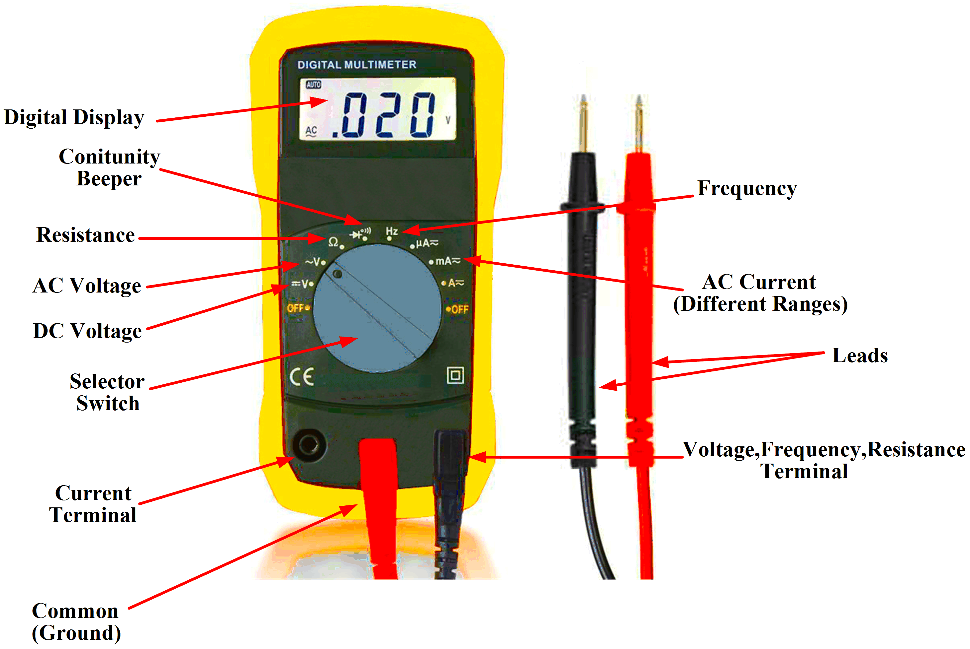

**CONCLUSION:**

In this experiment, We learned about the principles of electric circuits and the elements. We have also learned how PSpice is used to draw and simulate the circuit. To verify our measured value, we applied Ohm's law. We discovered what a multi-range meter is and how it works. We have learned how to use a multi-range meter to measure current, voltage, resistance, and so on. In our experiment, there were some discrepancies due to technical issues.

**Pre-Lab Repot Answer:**



